Homework 8

Self-feedback Schrodinger-Poisson solver

20171058 주휘인

Introduction

In this project, we used Self-feedback Schrodinger-Poisson solver to calculate electron density of double-gate MOS which has 6 nm thickness and 100 nm width. By using nonlinear Poisson equation, we can calculate electrical potential. With the potential calculated from nonlinear Poisson equation, we can calculate electron density using Schrodinger equation. By taking multiple loops of these sequence, we can get self-consistent Schrodinger-Poisson solution.

Result and Discussion

First, we get electron density calculated solely with nonlinear Poisson solver.

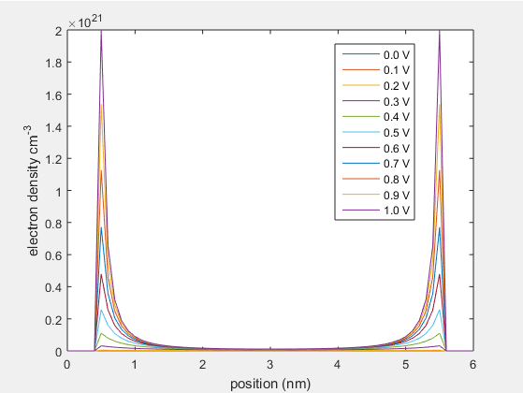

Fig.1 electron density calculated solely with nonlinear Poisson solver.

Next we calculated get electron density with Schrodinger-Poisson solver.

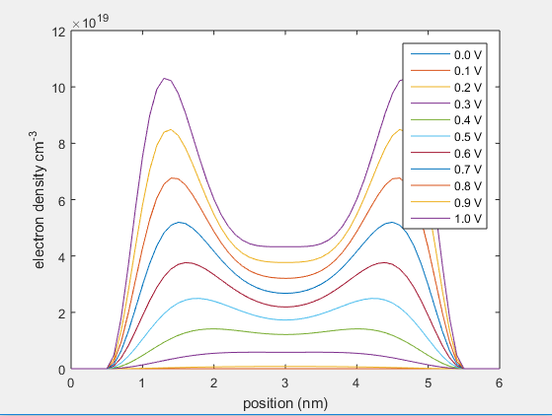

Fig. 2 electron density calculated with Schrodinger-Poisson solver

Comparing Figure 1 and Figure. 2, we can clearly see that electron density with respect to the position is highly different between the two solvers.

We also calculated the integrated electron density.

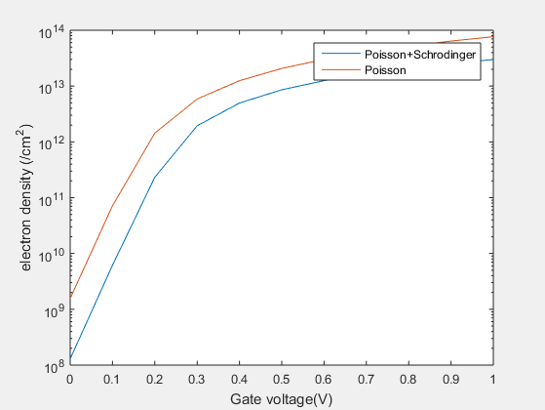

Fig. 3 Integrated electron density.

We can see that integrated electron density also shows a clear difference. We can find that almost one order of magnitude is different. This high difference might also mean that Schrodinger-Poisson solver might also have an error. Two graph seems like linear shift in log scale.